
POWERSHELL CMDS
ETHICAL HACKING

NAME : K NITHEESH KUMAR
REG N0 : 192325090

COURSE : ETHICAL HACKING
COOURSE CODE : ITA1416
POWERSHELL CMDS

August 3, 2026
SIMATS ENGINEERING
ComputerInfo
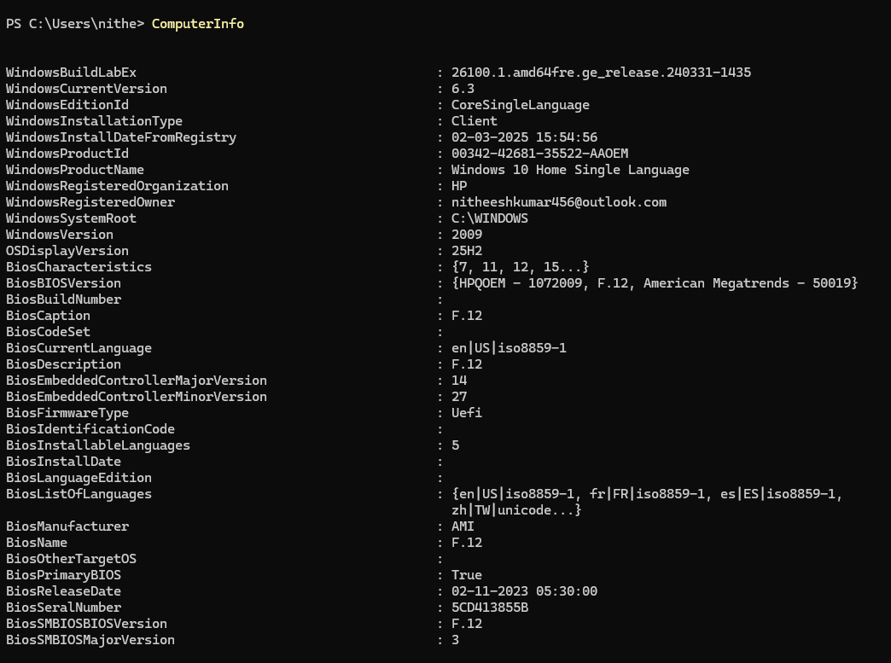

Disk
Volume
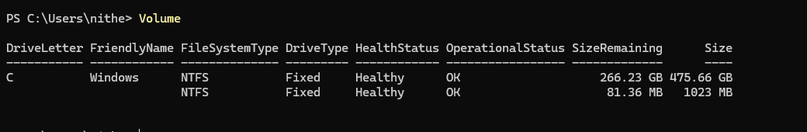

NetIPAddress
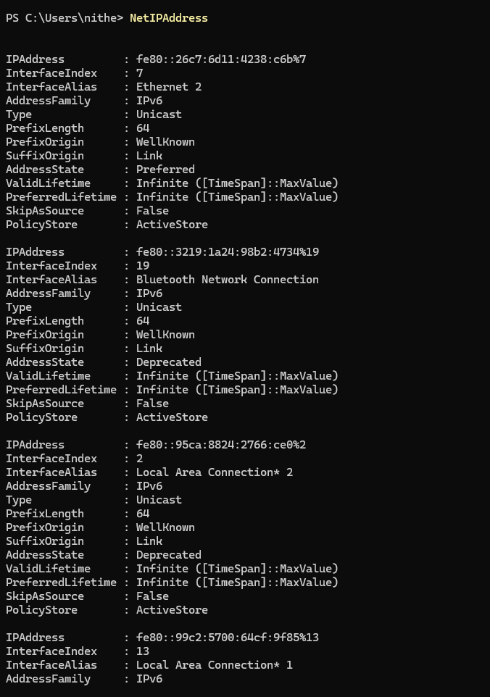

NetTCPConnection
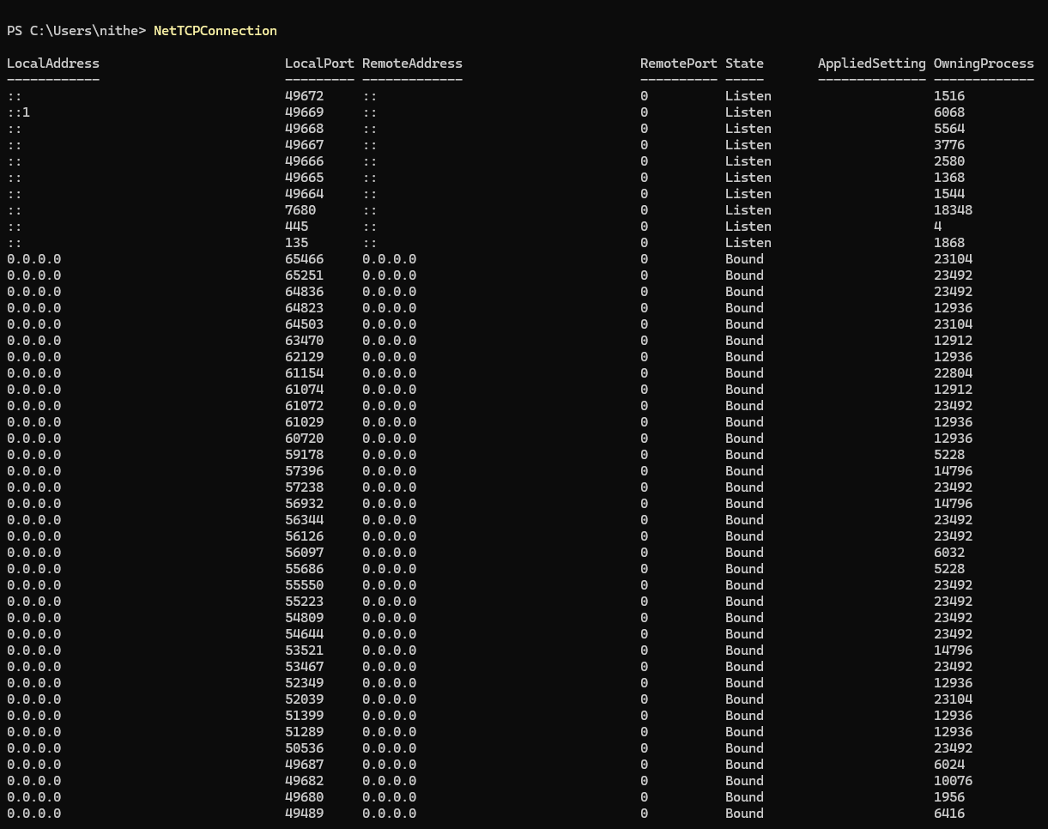

NetAdapter
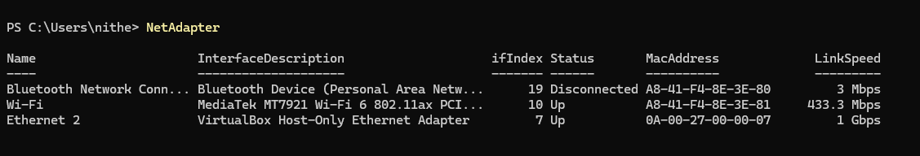

Service
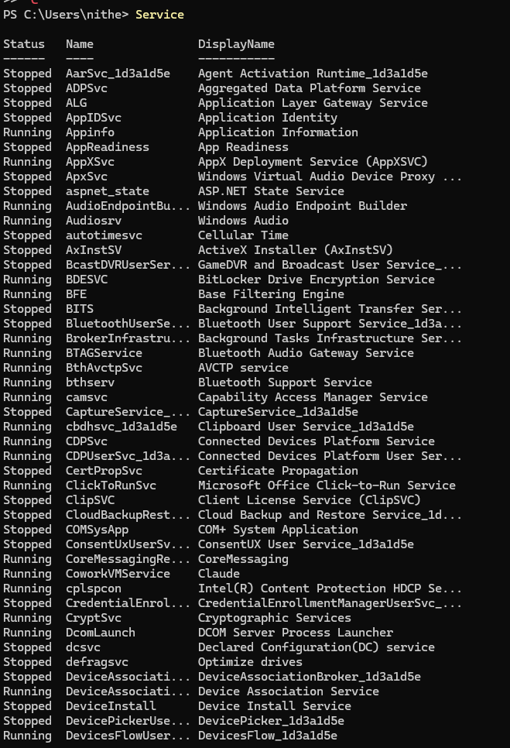
LocalUser
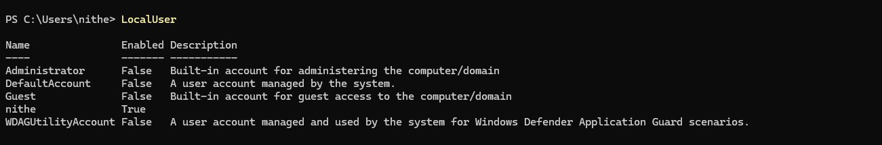
LocalGroup
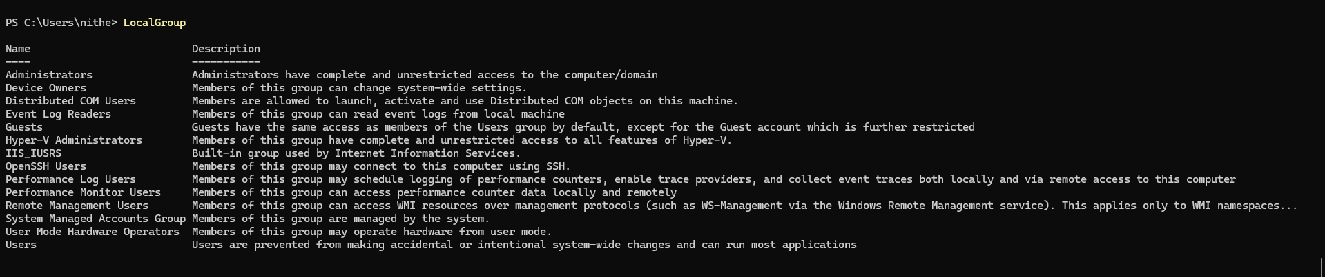
HotFix
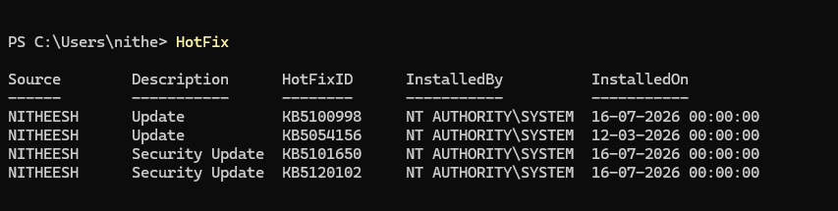

ScheduledTask
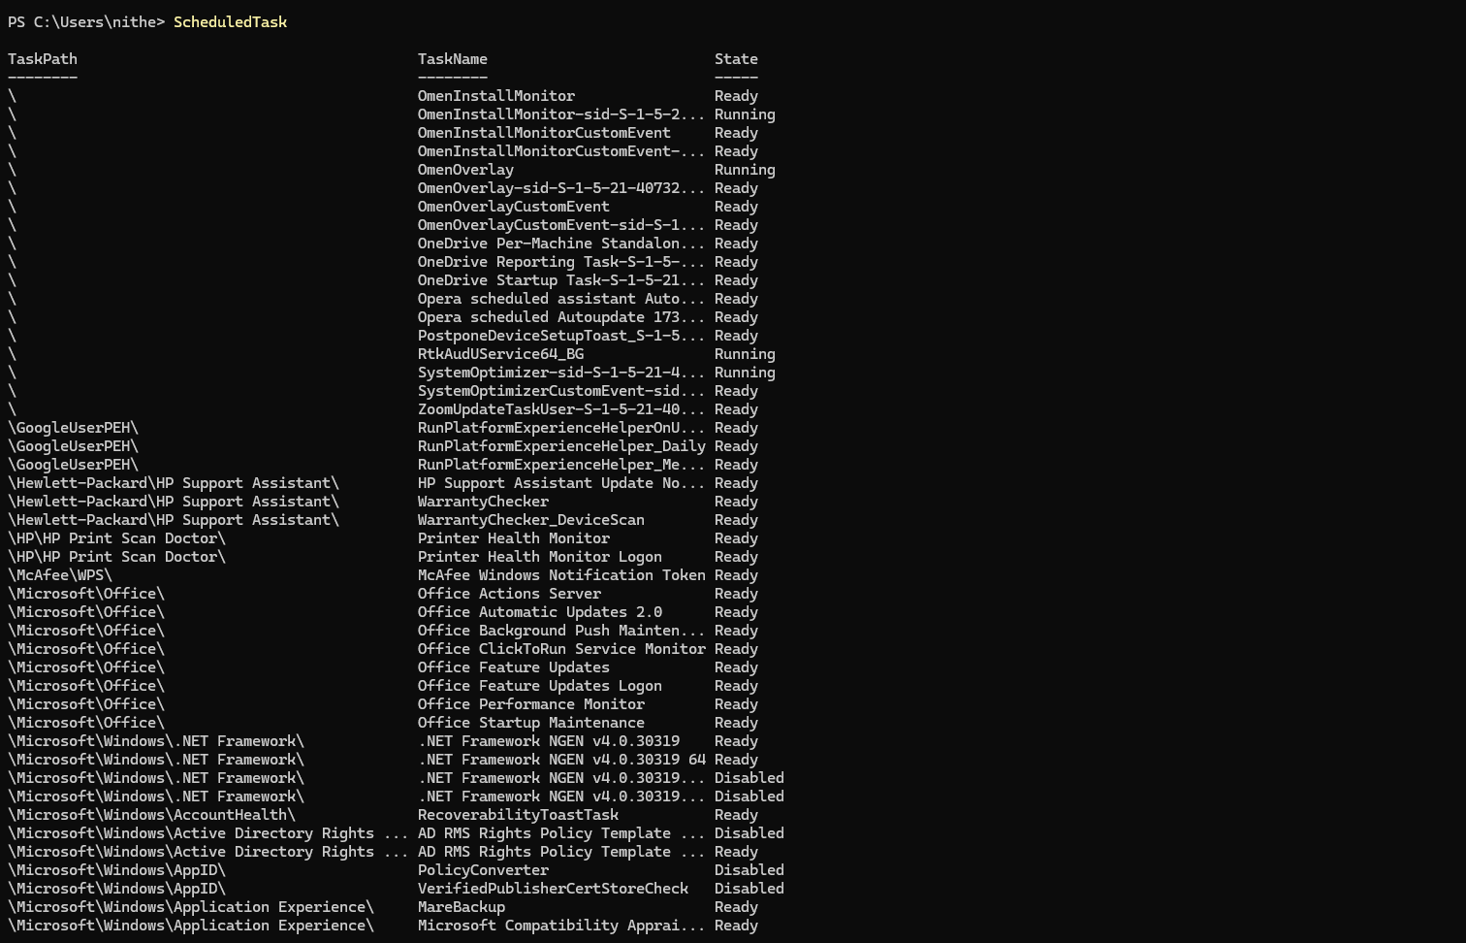

MpComputerStatus
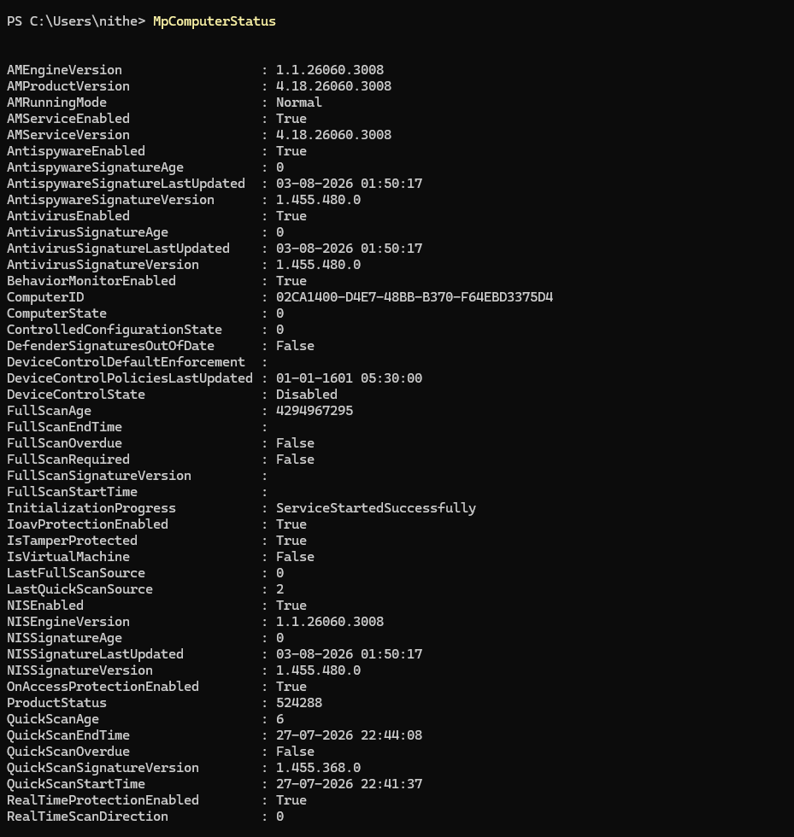

NetFirewallProfile
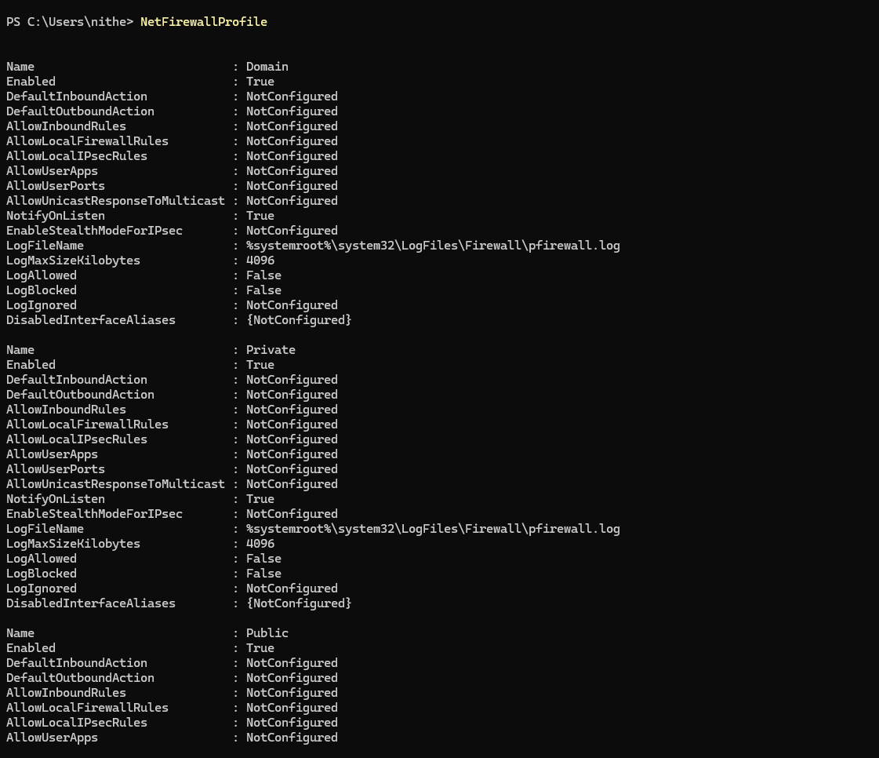

ChildItem
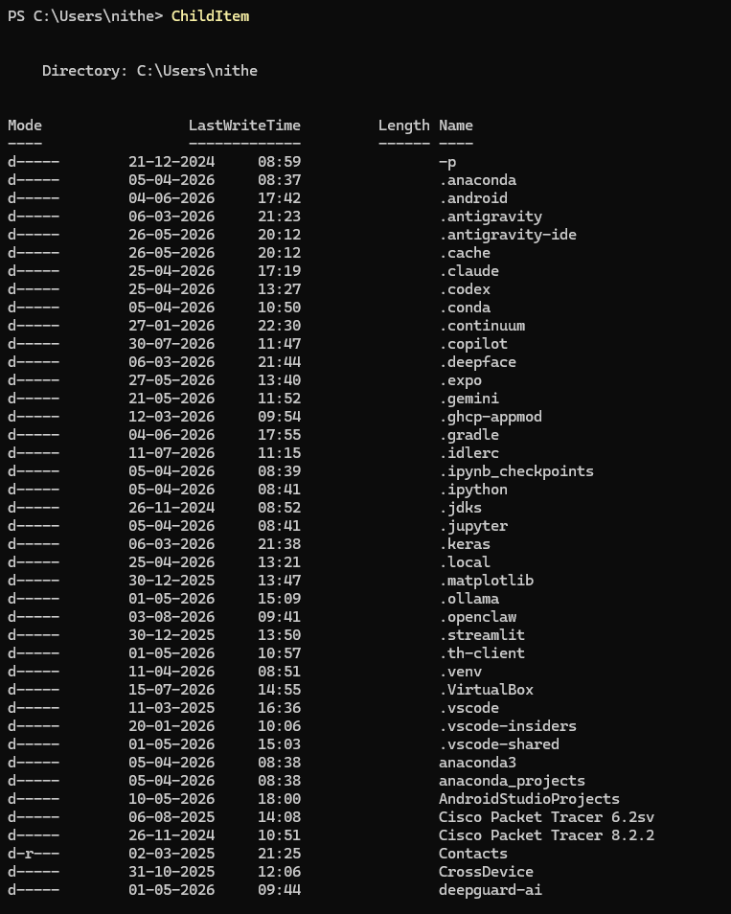

WinEvent
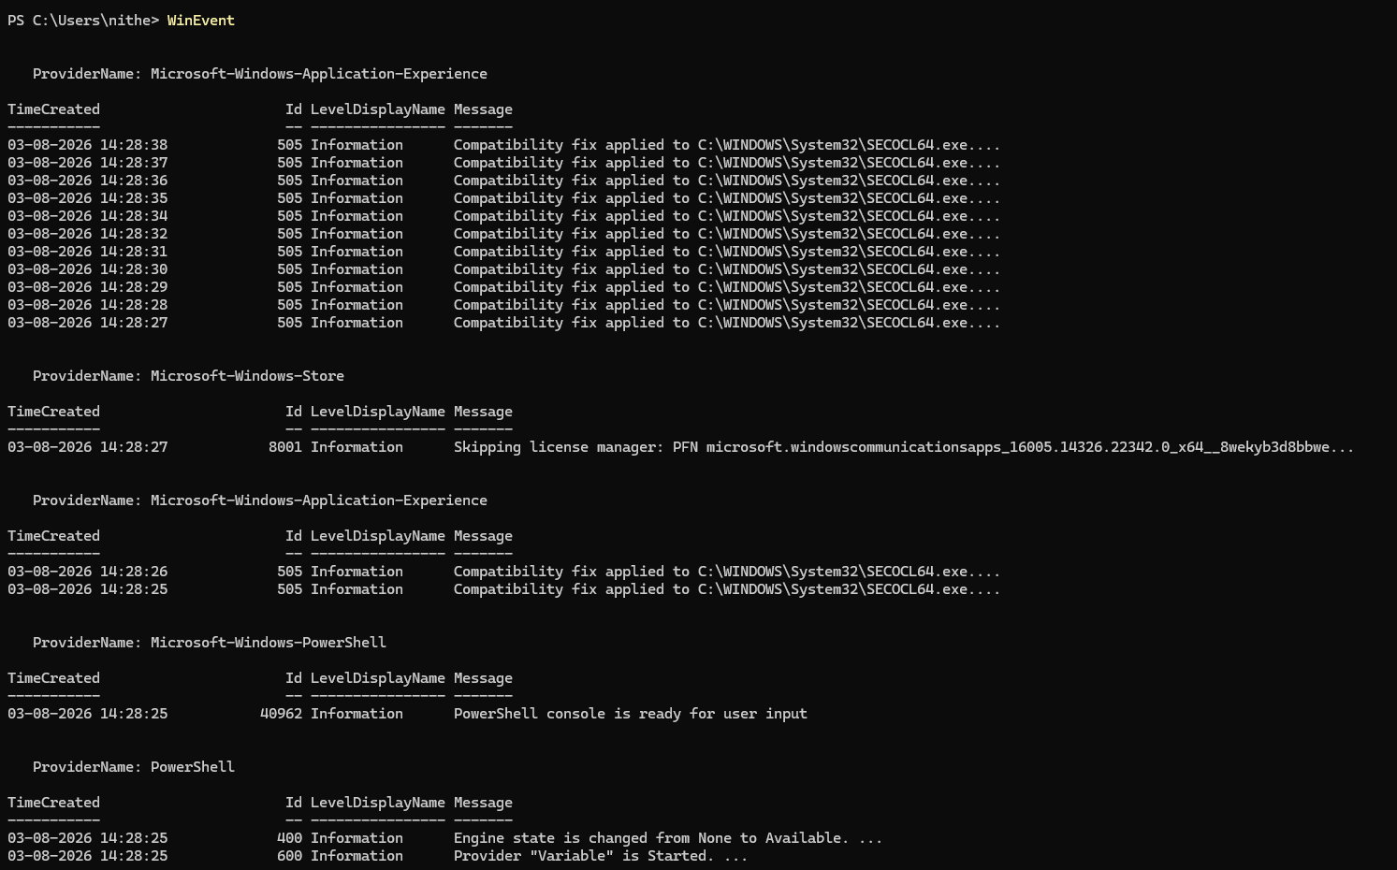
$PSVersionTable
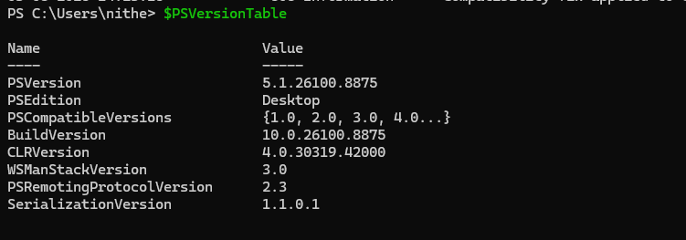

ItemProperty
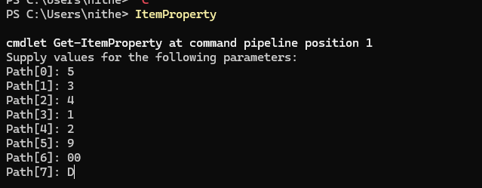
Package
